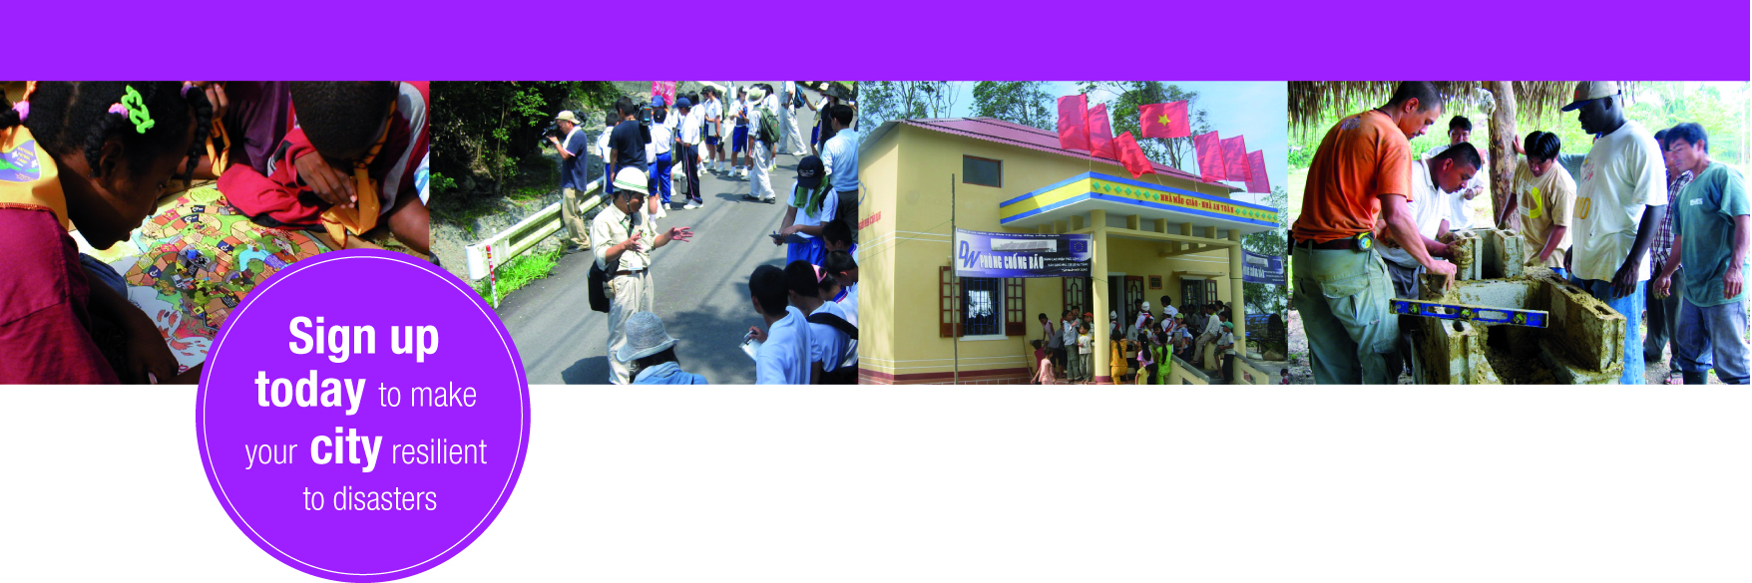

Become an advocate and be part of the resilient cities solution!

Advocate Application Form

Name and full contact details:

Educational background:

Languages spoken and written:

Field of expertise:

Disaster risk reduction related training experience and exposure:

Motivational letter (Approximately 600 words)

Additional guidance:
Advocate activities are open to discussion with UNISDR campaign team. A written motivational letter of who the advocate is and what are his/her expectations is requested in order to better shape campaign activities accordingly to the profile. A member of the campaign team will follow up with the advocate on participation details.

UNISDR will provide a virtual workspace for advocates and encourage participation in events.

